**2019-2021 Dungeness River winter steelhead SONAR-based escapement estimates**

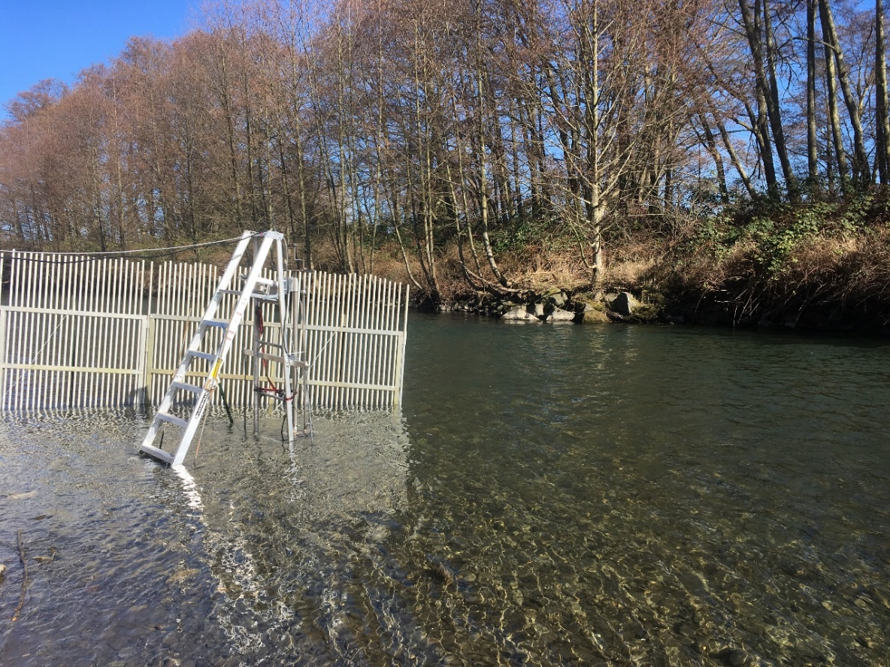

Bethany Craig and Joseph Anderson

The Washington Department of Fish and Wildlife

Draft Report

August 20, 2021

# Introduction

In 2019 the Washington Department of Fish and Wildlife (WDFW) installed and operated a stationary multi-beam SONAR unit in the lower Dungeness River to enumerate and gather run-timing information on winter steelhead (*Onchorhynchus mykiss*). Steelhead spawning ground surveys in the Dungeness River basin are inherently challenging due to springtime snow melt and rain events which can lead to high, turbid water and dangerous survey conditions. In most years it is not possible to survey for steelhead through the entirety of the spawning season, and in some years poor survey conditions prevent an adequate number of surveys to estimate redd-based escapement. SONAR may provide an alternative method for steelhead enumeration and run timing in a dynamic, turbid snow-melt system like the Dungeness watershed.

# Methods

## SONAR operation

In 2019, the SONAR unit was deployed at approximately river mile (RM) 0.3, below the majority of steelhead spawning habitat (Figure 1).

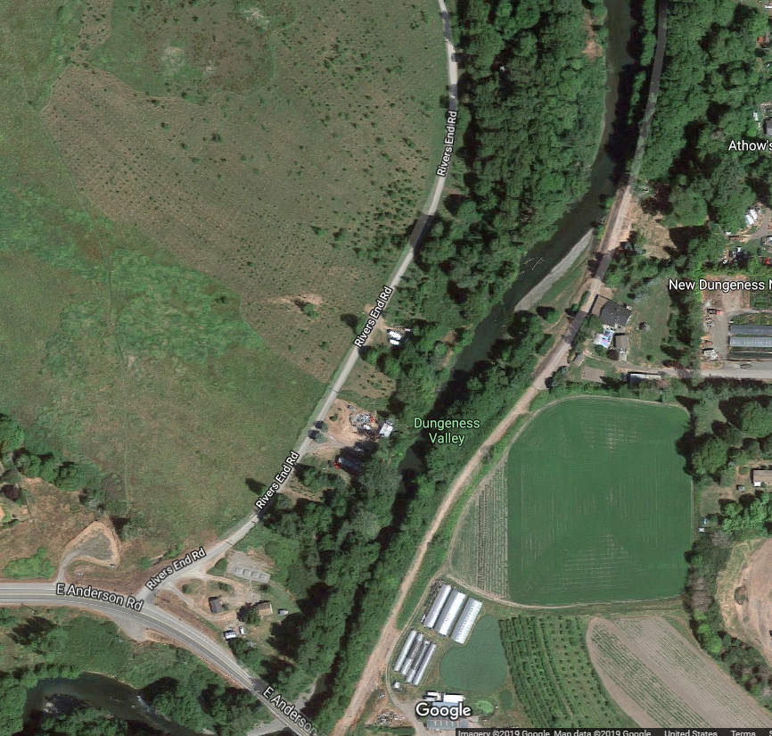

**Figure 1** Location of the SONAR site (white X) in the lower Dungeness River in 2019.

The SONAR was mounted to a pole mount and attached to a reinforced ladder, secured to the river bottom by rebar (Figure 2). The SONAR was placed along the hardened left bank, in a spot that was protected, but that retained adequate depth so that the SONAR unit and ladder did not need to be shifted laterally to accommodate changing water levels. The SONAR site ensonified an approximately 20 meter (m) wide run in the river that fish actively migrate past, reducing the possibility of milling or holding fish. This site was easily accessible from the field trailer site, which enabled the unit to be directly connected and powered by trailer power, and any adjustments to the SONAR settings to be accomplished in the dry, safe comfort of the trailer.

A picket weir was constructed approximately 1 m above the SONAR unit from the bank to approximately 1 m past the SONAR to deflect debris and help direct migrating fish out in front of the unit.

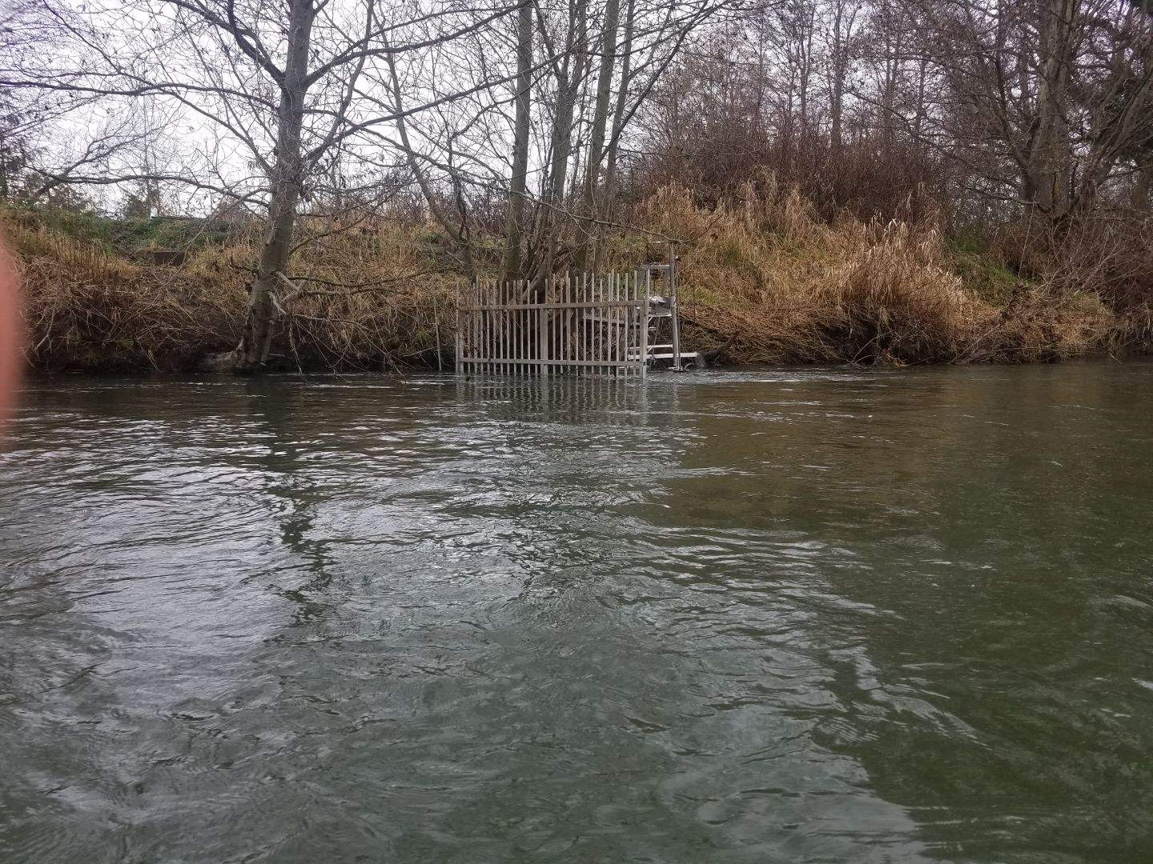

**Figure 2** ARIS 1800 SONAR unit deployment in the Dungeness River.

We deployed the ARIS 1800 Explorer, manufactured by Sound Metrics, of Bellevue, Washington. The ARIS 1800 uses 96 beams to project an acoustic wedge that ensonifies the water column. The SONAR unit was adjusted to have a pitch of 3.5 degrees to -8 degrees to ensonify the entire water column and was checked daily and adjusted as necessary to maintain full ensonification of the channel. Imagery was continuously recorded 24 hours a day, and saved in 30-minute files, so that 48 individual files were recorded for each full day of operation.

The SONAR was operated continuously from March 5, 2019 until October 10, 2019. This report focuses on the steelhead migration period between March 5 and June 24th, 2019. From March 5th to June 24th, there were 8 days with partial data recording gaps (7% of 112 days). Four of these gaps were 1 hour or less; the other 2 data gaps ranged from approximately 18 hours (March 9 and 10) to 20 hours (April 9 and 10, Figure 3a).

**Figure 3** a) Percent of SONAR imagery data recorded by day in 2019; b) SONAR imagery data reviewed for fish passage at 30 minutes per hour (gray, first 30 minutes of each hour), and at 60 minutes per hour (black, entire hour reviewed).

## Species composition

No regular species composition sampling was conducted in 2019. Three sampling efforts targeting bull trout were conducted once per week in June at sites throughout the Dungeness and Gray Wolf rivers.

SONAR fish targets ≥ 45 cm were marked and counted as possible steelhead based on 4 years of length data from steelhead genetic sampling surveys in the Dungeness (Table 1, Figure 6).

HOR/NOR- no hatchery-origin steelhead were captured during 2021 species composition sampling

## Data processing

The first 30 minutes of each hour were processed and reviewed for fish migration. This subsampling scheme enabled the SONAR project team to keep up with data review throughout the season, and to complete a review of the entire steelhead migration period. Fourteen days were fully reviewed (60 minutes of each hour) to compare fish migration with subsampled (30 minutes of each hour) data (Figure 3b). Each reviewed imagery file was processed using Sound Metric’s proprietary software ARISFish (v2.6.3). First, raw image files were background subtracted, which removed static objects from the image so that only objects in motion are shown. Then, an echogram was created, which transformed the image into a graph of distance (y-axis) and time (x-axis), so that objects in motion appeared as white “tracks.” The echogram enabled the data reviewer to quickly navigate to parts of the image file that contained objects that could be migrating fish. These tracks were then manually viewed alongside the raw image file to determine if the object was a fish to be further investigated.

Fish greater or equal to 45 centimeters (cm) were measured, marked, and counted using the ARISFish software. Forty-five cm was determined to be the minimum length of a potential steelhead, based on captures of steelhead during sampling in the Dungeness River 2014, 2015, and 2017 by the Jamestown S’Klallam Tribe (JSK) (unpublished data, C. Burns). Only fish that completely moved through the SONAR beams were counted; fish that nosed in and out or did not completely move from one side of the beams to the other were not counted. For each fish counted the following data were recorded:

* Date
* Hour of the 30-minute image file (e.g., 14:00, 14:30)
* Time
* Frame
* Direction of travel (upstream or downstream)
* Range (distance from the SONAR)
* Length of the fish in cm
* Data reviewer confidence (1= extremely confident that the object counted is a fish ≥ 45 cm, 2= somewhat confident that the object is a fish ≥ 45 cm, 3= object of interest)

If no fish were observed in the 30-minute image file, a line of data with “NO FISH” was recorded to indicate that the file was reviewed for fish, but no fish ≥ 45 cm were present. Marked fish were automatically saved within the image file for later error checking; data were also recorded within an Excel spreadsheet for data summarization and analysis.

## Escapement estimation

SONAR fish targets that were ≥ 45 cm, moved completely through the SONAR beams (direction of travel = upstream or downstream), and had a data reviewer confidence = 1 were included in the final fish counts and escapement estimate. Daily net upstream passage was calculated by subtracting the number of downstream moving fish from the number of upstream moving fish. Steelhead escapement was estimated by the sum of daily net upstream passage from March 5, 2019 to June 24, 2019. TBD- may add in kelt adjustments.

### Species composition

TBD- we could downgrade June counts as mostly bull trout based on June 2019 sampling and knowledge of 2021 sampling

### Data reviewer comparisons

To be written- thus far just observations of data reviewer consistency. The official fish counts for shared data days were all fish both reviewers agreed to (88%), with AS (“expert”) data (time, distance, etc.) and an average of fish length. These fish lengths were not included in length distributions.

### Adjustments for kelts

TBD

### Accounting for missing data

Fish counts missed during data recording gaps of one hour or less were estimated from fish counts from two hours on either side of the missing data (Table 1). Fish counts missed during data recording gaps greater than one hour were estimated by XX.

**Table 1** SONAR data gaps and method used to estimate missed data in 2019. Data gap time periods are approximate.

|  |  |  |
| --- | --- | --- |
| Date | Data gap | Method to estimate missed data |
| March 7 | 60 minutes | Fish counts 2 hours on either side of gap |
| March 8 | 12 minutes | Fish counts 2 hours on either side of gap |
| March 9 & 10 | 18 hours | TBD |
| March 14 | 50 minutes | Fish counts 2 hours on either side of gap |
| March 21 | 10 minutes | Fish counts 2 hours on either side of gap |
| April 9 & 10 | 20 hours | TBD |

### Expansion of sampled data

TBD.

# Results and discussion

## Fish migration

Steelhead sized fish were present immediately upon deployment of the SONAR on March 5th, 2019. (Figure 4.) Total raw daily counts of fish, from the first 30 minutes of each hour, ranged from 1 fish to 23 fish. On average 6 fish moved upstream daily, with a range from 0 to 15 fish; downstream fish counts averaged 2 fish daily, with a range from 0 to 10 fish. Net fish movement was upstream over the course of the steelhead migration period, and daily net upstream counts peaked in mid-April (Figure 5). Beginning in early May, and continuing until the end of June, net upstream movements decreased, and net downstream movements became more common, suggesting steelhead were kelting. Raw net upstream fish passage from March 5, 2019 and June 24, 2019 equaled 382 fish.

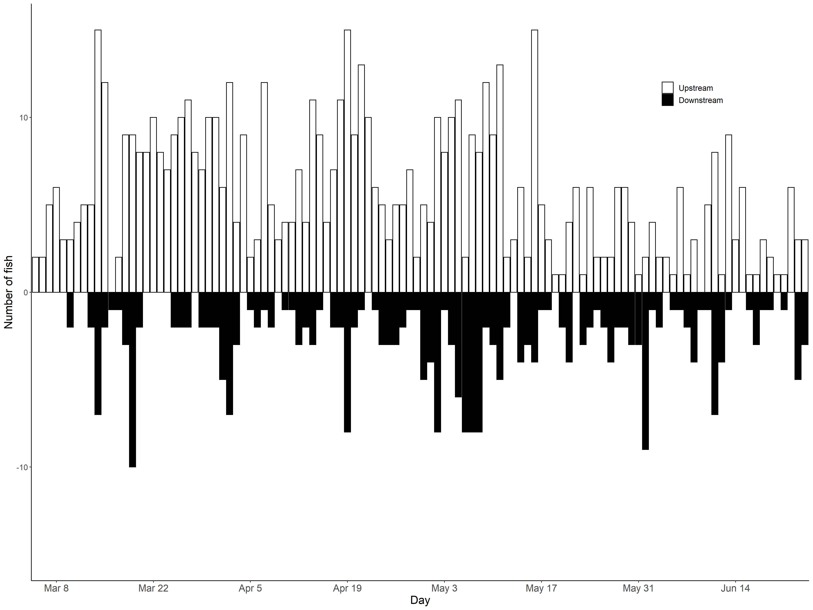

**Figure 4** Raw daily fish counts from the first 30-minutes of every hour from the Dungeness River SONAR in 2019. White bars are upstream counts; black bars are downstream counts.

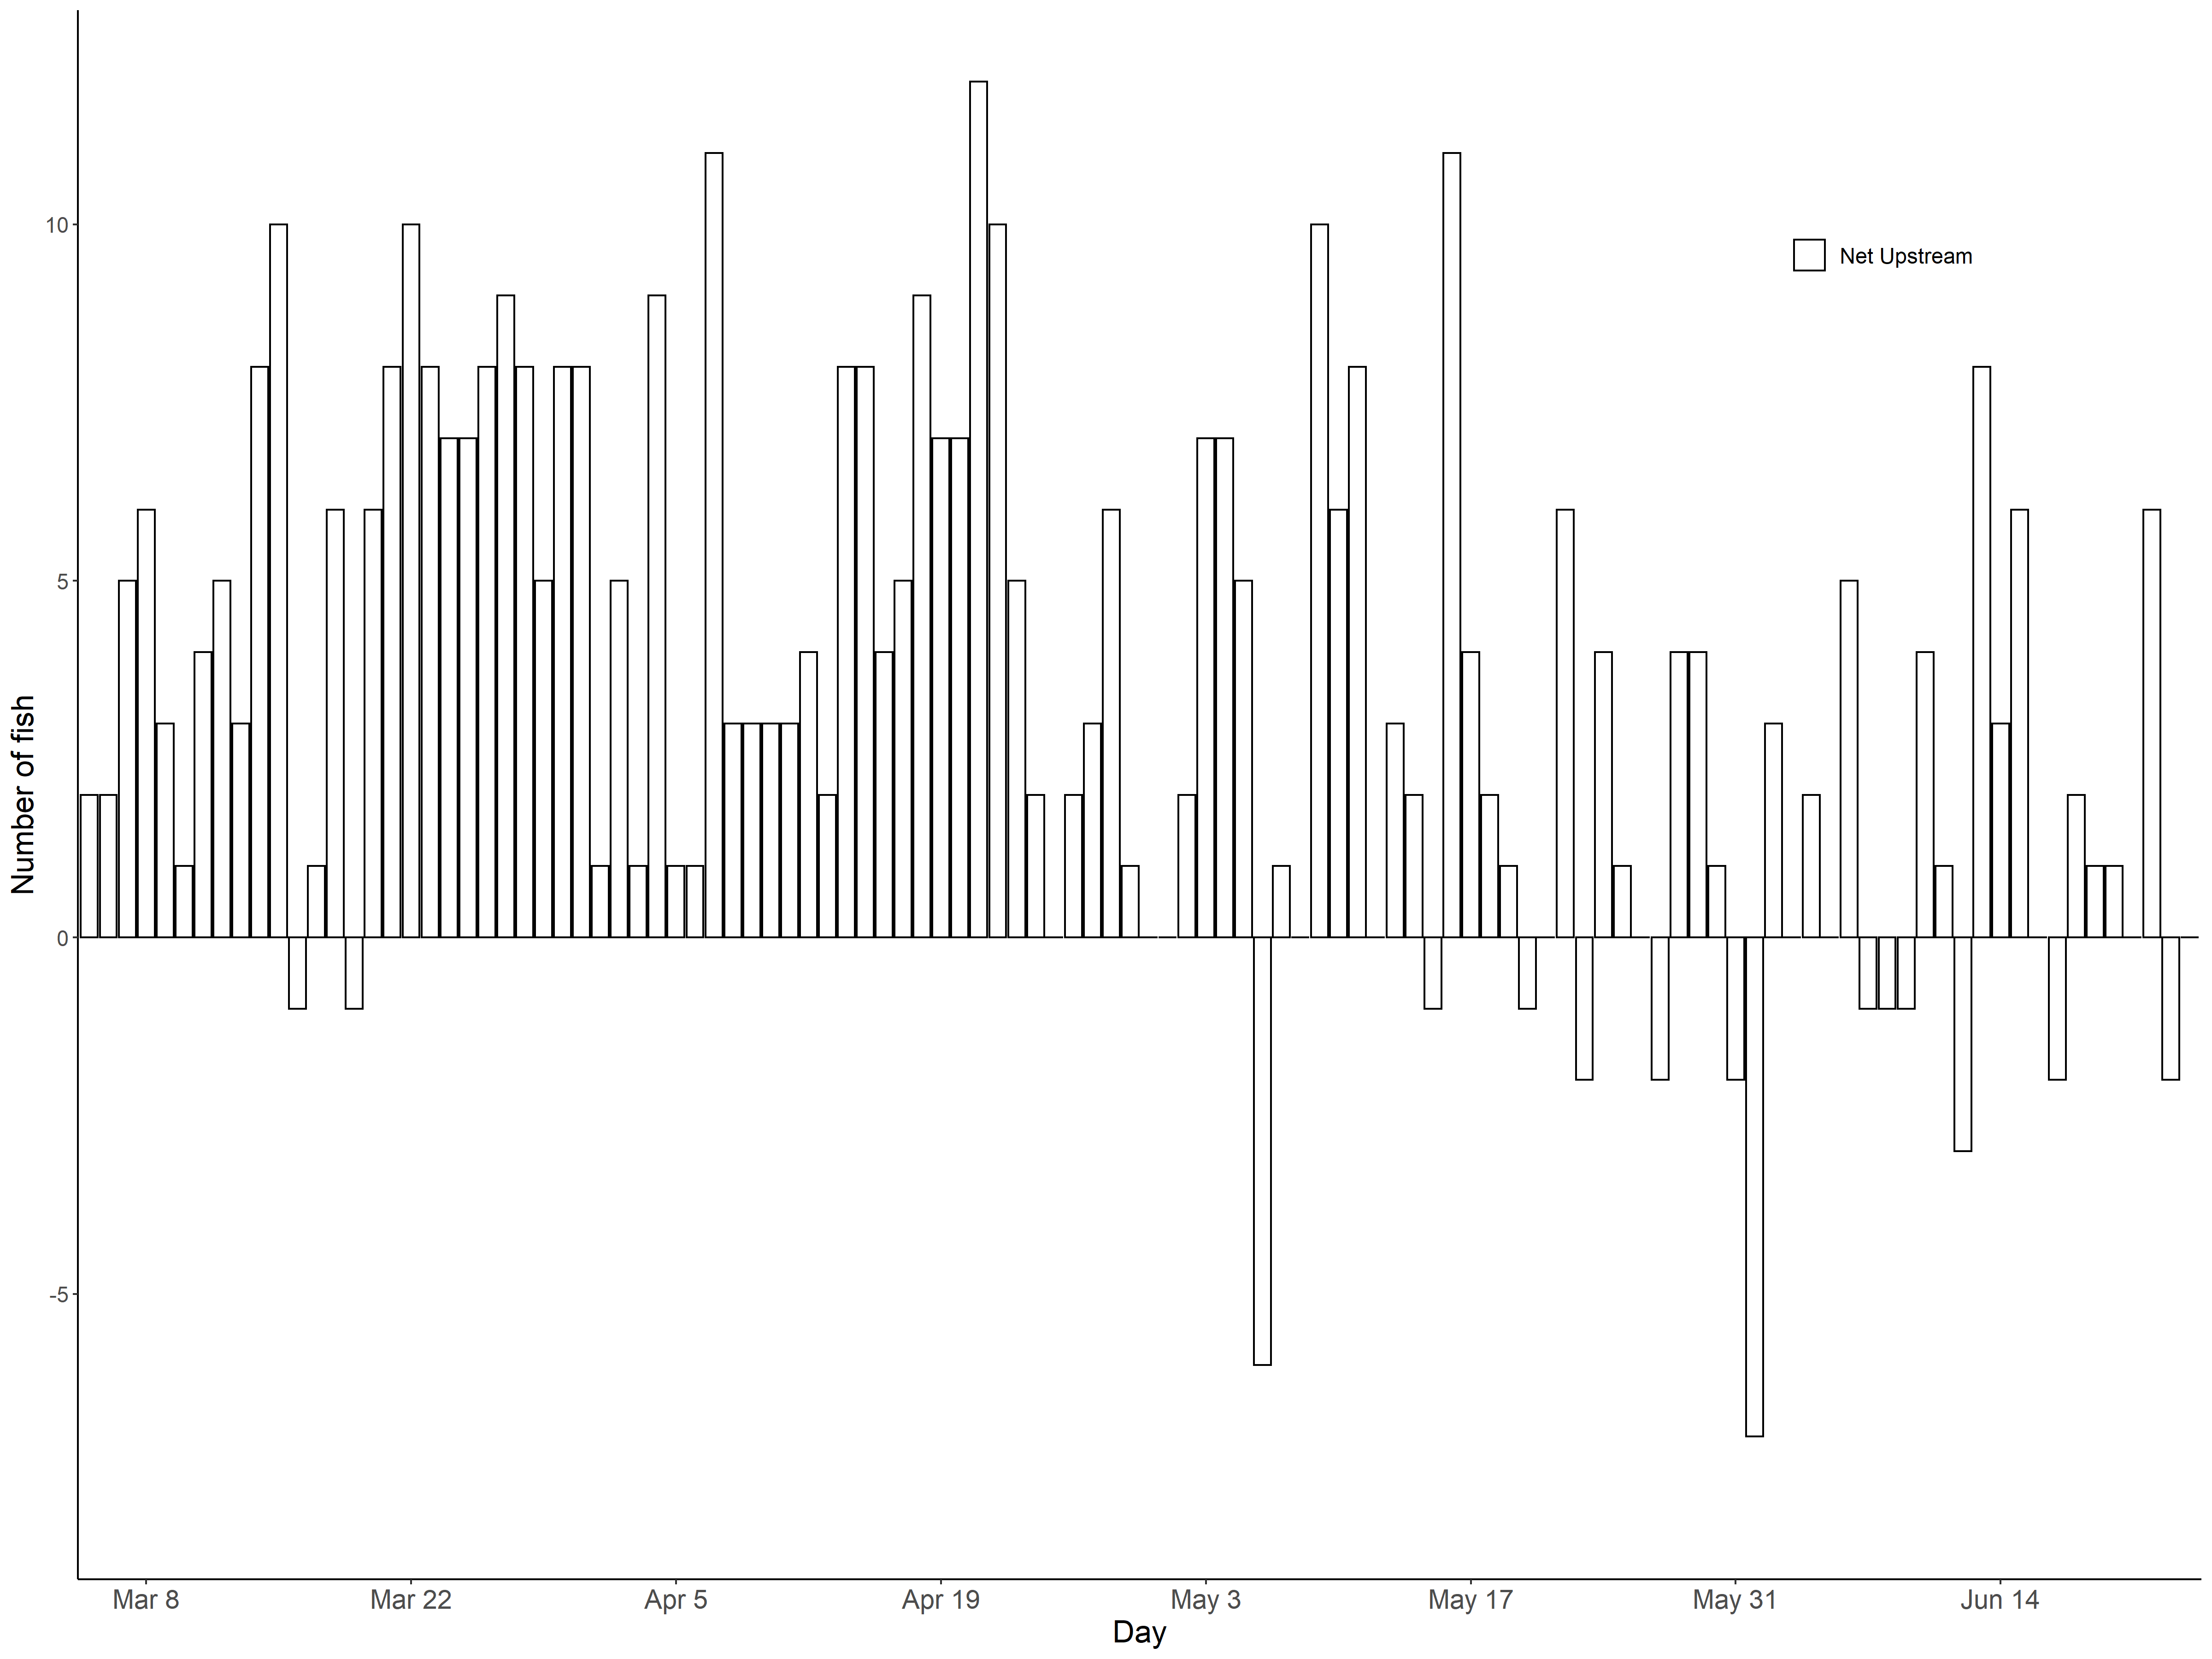

**Figure 5** Raw net daily fish counts from the first 30-minutes of every hour from the Dungeness River SONAR in 2019. Positive bars indicate net upstream movements; negative bars indicate net downstream movements.

## Fish size distributions and species composition

As stated above, no regular species composition sampling was performed in 2019. No steelhead were captured or observed during 3 sampling efforts in June targeting bull trout (Table 2). Twenty-four bull trout and 1 resident rainbow trout were captured and sampled during these efforts.

**Table 2** Bull trout- targeted sampling efforts in the Dungeness and Gray Wolf rivers in June 2019. Sampling occurred via both tangle net and angling.

|  |  |  |  |  |
| --- | --- | --- | --- | --- |
| Date | Sites | Bull trout | Steelhead | Rainbow trout |
| June 11 | Lower Gray Wolf River,  Hatchery outlet | 13 | 0 | 1 |
| June 18 | Highway 101,  Old Olympic Highway | 9 | 0 | 0 |
| June 25 | Old schoolhouse,  SONAR site | 2 | 0 | 0 |

The size of fish passing the SONAR averaged 71.8 cm ± 10.6 cm (Table 3, Figure 6). SONAR targets were 5.9 cm larger on average than steelhead fork lengths (FL) as measured during past angling efforts (Table 3, Figure 6). Based on past sampling efforts, both bull trout and pink salmon overlapped in size with steelhead up to 61 cm and 57.5 cm FL, respectively, whereas Chinook overlapped in size with steelhead over the entire steelhead distribution (Table 3, Figure 6).

**Table 3** Length distributions of steelhead, bull trout, Chinook salmon, and pink salmon sampled in the Dungeness River.

|  |  |  |  |  |  |  |
| --- | --- | --- | --- | --- | --- | --- |
| Species | Mean FL (cm) | Range FL (cm) | N | Sample type | Sample years | Sample source |
| SONAR1 | 71.8 ± 10.6 | 45.6 – 100.8 | 1049 | Live, SONAR | 2019 | WDFW |
| Steelhead | 65.9 ± 7.4 | 46.0- 93.0 | 81 | Live, angling | 2014, 2015, 2017- 2018 | JSK |
| Bull trout | 44.4 ± 9.2 | 25.0 – 61.0 | 58 | Live, angling | 2001-2002, 2015, 2017- 2018 | JSK, WDFW |
| Chinook | 75.5 ± 9.7 | 37.0- 100.0 | 311 | Carcass | 2017 | WDFW |
| Pink | 46.7 ± 3.5 | 39.0 – 57.5 | 122 | Carcass | 2015 | WDFW |

1 SONAR lengths are from fish targets included within the final fish counts.

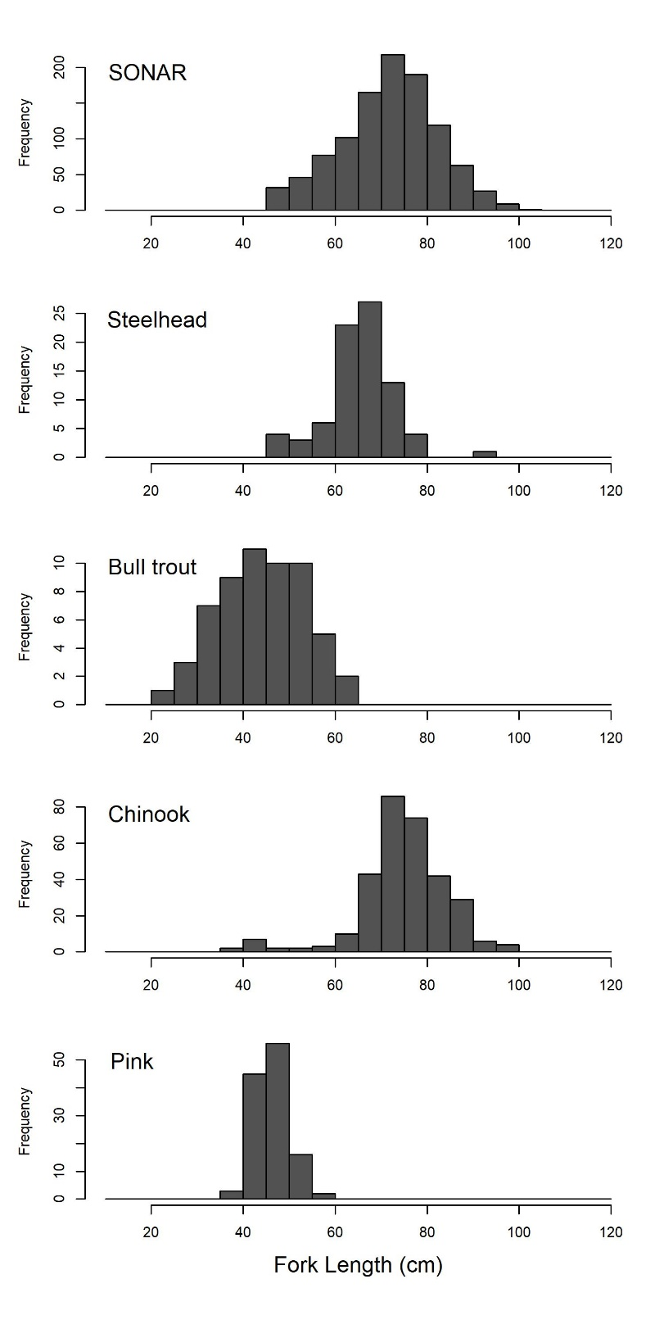

**Figure 6** Length distributions of SONAR fish targets from 2019, and bull trout, Chinook salmon, and pink salmon from past sampling efforts in the Dungeness River.

## Data reviewer comparisons

Five days of data were triple reviewed by the two primary data reviewers and a third data reviewer to compare counts and measurements among the reviewers. The two primary data reviewers marked 88% of the same fish (Table 4). Reviewer 1 consistently measured fish as larger than Reviewer 2 (93% of the time), by an average of 6.4 cm. Twenty-three percent of fish lengths were highly variable between the two primary reviewers, mainly on days with poor image quality. Fish counts and lengths were more variable between all three reviewers (Table 5). Upstream migrating fish counts were more consistent than downstream counts for all three reviewers.

**Table 4** Comparison of fish counts for 5 days of data by the two primary data reviewers.

|  |  |  |  |  |  |  |
| --- | --- | --- | --- | --- | --- | --- |
|  | Agreed-to fish counts | | | Percent of agreed-to fish counts | | |
| Number of observers | Downstream | Upstream | Total | Downstream | Upstream | Total |
| 2 of 2 | 5 | 37 | 42 | 50% | 97% | 88% |
| 1 of 2 | 5 | 1 | 6 | 50% | 3% | 13% |
| Total fish marked | 10 | 38 | 48 |  |  |  |

**Table 5** Comparison of fish counts for 5 days of data by three data reviewers.

|  |  |  |  |  |  |  |
| --- | --- | --- | --- | --- | --- | --- |
|  | Agreed-to fish counts | | | Percent of agreed-to fish counts | | |
| Number of observers | Downstream | Upstream | Total | Downstream | Upstream | Total |
| 3 of 3 | 2 | 36 | 38 | 15% | 90% | 72% |
| 2 of 3 | 6 | 1 | 7 | 46% | 3% | 13% |
| 1 of 3 | 5 | 3 | 8 | 38% | 8% | 15% |
| Total fish marked | 13 | 40 | 53 |  |  |  |

## Expansion of sampled data to escapement estimate

TBD.

# Recommendations

* Deploy the SONAR in early to mid- February, as river conditions allow, to capture the earlier component of the steelhead run
* Conduct species composition netting 1-2 times per month during SONAR deployment to adjust daily fish counts by percent steelhead and to determine the end of the steelhead migration
* Account for steelhead kelts in escapement estimate
* Investigate potential collaborations with external partners to leverage machine learning/AI to automatically count and measure fish and reduce data processing time

# Acknowledgements

Andrew Simmons and Jayson Gallatin of WDFW operated, maintained, and reviewed 2019 SONAR imagery data. Peter Topping and Joseph Anderson provided project support and advice. Many thanks to Scott Williams, David Thomas, and Jeff Gufler who assisted with the June bull trout sampling. Thanks as well to Aaron Brooks, Chris Burns, Jarrett Burns, and Casey Allen of the Jamestown S’Klallam Tribe, and to Roger Peters, Kathryn Sutton, and Roger Tabor of the U.S. Fish and Wildlife Service for help with sampling efforts. The U.S. Fish and Wildlife Service loaned their net and sampling gear for the bull trout netting efforts.